|  |  |
| --- | --- |
|  |  |

**Group A : Brief Answers [5× 2 = 10 Marks]**

1. Why Indifference Curve is downward sloped to the right?

Answer: Due to diminishing Marginal Rate of Substitution (MRS), Indifference Curve is downward sloped to the right as highperbola where, any point laying on such curve yield same level of satisfaction to the consume. MRS is the the rate of change of one commodity for another commodity to maintain same level of satisfaction.

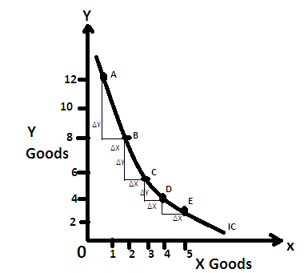

As in the figure, Marginal rate of substation of X for Y is decreasing, which is seen as change in Y is decreasing if we look from point B to C in comparison to A to B point. Similarly in point D to E in comparison to C to D. Here at point A, consumer has 12 units of Y good and 1 unit of X good but as consumer reaches at B point, s/he gives off 4 units of Y good to get 1 unit additional of X good, similarly at point C, consumer gives off 3 units of Y good to obtain 1 unit additional of x. similarly at point E, s/he gives off 2 unit of Y good to get 1 additional unit of X good. So Rate of giving off of Y good is continuously decreasing to obtaining 1 additional unit of X good which is shown by Rate of Change in Y, which is continuously decreasing if it goes down from point A to rightward ie. point B, C, D and E to get one additional unit of X good.

1. Define Giffen goods.

Answer: The Goods with positive relationship between its price and demand as well as negative income effect are called Giffen good.( or the goods with positive price effect and negative income effect are called giffen goods). **Those goods which are non-luxury and inferior but very little or no close substitute with positive price effect are called giffen goods.**

(During the British(Scootish) Industrial revolution, a study was made by Sir R. Giffen and found that when price of goods increased, demand of that good was also increased, which was against the law of demand as Marshall said when prices rises demand of good will fall. So this paradox of Giffen is against the law of demand and such types of goods are called giffen goods: Bread)

Bread is a classic example of such goods because if the price of bread increases, the poor people will still buy more bread because he cannot afford other luxury items such as meat.

**All Giffen goods are inferior goods but all inferior goods are not Giffen. Explain**

Answer: The goods which are negative income effect (IE) are called inferior goods and all Giffen goods have negative income effect(IE). So, all Giffen goods are inferior goods. However income effect is not sufficient condition for Giffen goods. The sufficient condition for Giffen goods required that IE > SE. There are such goods which have negative income effect, which means they are inferior but if we compare SE and IE, we find that IE <SE. Therefore these goods are only inferior but not Giffen.

1. What are the conditions that a consumer attains maximum satisfaction under the cardinal utility approach?

Answer: A consumer attains maximum satisfaction given his resources and other conditions under the cardinal utility approach is at the point where **Marginal utility of commodity is equal to marginal utility Money**; which can be seen under 3 different conditions are:

1. In one commodity model, a consumer gets maximum satisfaction, where **MUx=P(MUm)** or **MUx/P(MUm)=1**
2. Two commodities model (say X and Y), a consumer gets maximum satisfaction at the point where weighted marginal utilities of selected 2 commodities are equal to each other and also equal to marginal utility of money. i.e.**, MUx/Px=MUy/Py=K** (K=Marginal utility of given money income)
3. Multiple commodities model (say X, Y,…n), a consumer gets maximum satisfaction at the point where weighted marginal utilities of selected commodities are equal to marginal utility of money. i.e. , **MUx/Px=MUy/Py=……..=MUn/Pn = K** (K=Marginal utility of given money income)
4. Define the law of Diminishing Marginal Utility.

Answer:

Answer: The law of Diminishing Marginal Utility states that when a consumer consumes more or more units of a commodity, Utility obtained from each additional unit goes on falling.

**or,**

"The additional benefit which a person derives from a given stock of a thing diminishes with every increase in the stock that he already has." Marshall

1. Differentiate between Microeconomics and Macroeconomics.

|  |  |
| --- | --- |
| **Microeconomics** | **Macroeconomics** |
| **Microeconomic studies the individual or small economics variables of the economics such as Individual consumption, saving, investment and income.** | **Macroeconomics studies the aggregate aspect of the economics such as National Income, Full employment, price level, Aggregate Demand and Aggregate Supply.** |
| **It aims to study the principles, problems and policies concerning the optimum allocation of resources.** | **It aims to study the principles, problems and policies concerning the full employment and growth of the economy.** |
| **The subject matter of microeconomics is to study the determination of price, consumers equilibrium, distribution and welfare etc. so it is called price theory** | **The subject matter of microeconomics is to study the process of determining employment price level, National income, trade cycle etc. so it is called income and employment theory** |
| **It is called partial equilibrium analysis.** | **It is called General equilibrium analysis.** |

**Group B : Long Answers (any Three) [3×10 = 30 Marks]**

1. Is economic analysis rest on the problem of scarcity and choice? Explain it.

Answer: Yes, Economic analysis rest on the problem of scarcity and choice.

The starting point of economic analysis is the existence of human wants. Human wants refers to the needs of the people with ability to pay and willingness to pay. Human wants are unlimited and never ending. If one want fulfills, another wants will appear. This process is never ending throughout the human life. Thus human wants not only recur but also multiply endlessly as society grows.

To satisfy wants of human being, goods and services are needed. To produce goods and services, resources are to be used during the production process. Land, Labor and capital are the resources, needed during the production process but these resources are scares. Scarcity refers to the limited supply of productive resources in relation to their demand. These productive resources can be used in alternative production process. Thus productive resources are to be used optimally, which need to choose these productive resources wisely. Thus choice is to be made for using productive resources in the best alternative production process. Choice refers to a process of selecting highly urgent want from unlimited wants in order to achieve maximum satisfaction through optimum allocation of limited resources. If careful use of scarce resources is not applied in the production process, society cannot get the benefit optimally. So, choice of using limited resources is fundamentally important for the betterment of society. Economic analysis focuses on allocation of limited-resources optimally for society's or firm's objective maximization. Choice is linked with economic phenomenon in production as well as in consumption too. As a society cannot produce enough goods and services to satisfy all wants of its people, it has to make choices. A decision to produce one good requires a decision to produce less of some other good because of limited resources.

**Figure 1:**

**Scarcity and Choice**

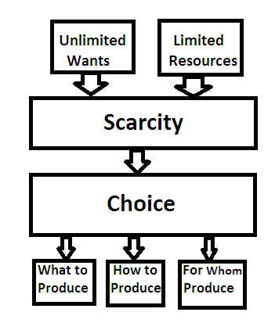

Human wants are limitless and to fulfill human wants by consuming the goods and services, resources are limited which can be seen in Figure 1. As resources are scare, all wants are not fulfilled simultaneously; only urgent wants are to be fulfilled by using limited resources. Thus, choice is to be made in consumption of goods and services in daily life of human being. Economic analysis helps to consumers for making choice easy on goods and services with optimal resources allocation. On the one side economics analysis is helpful to consumers for maximization of their utilities; on the other hand, it provides guideline to producer for allocation of scare resources optimally so that objective of the producer can be fulfilled.

The main economic problems arisen from the scarcity of resources are: what to produce, how to produce and whom to produce. What to produce refers to those goods and services and quantity of each that economy should produce. The price mechanism solve the what to produce problem in the open economy. Only those goods and services are produced, where consumers are willing to pay the price of the product as price of product recovers all the cost of production process. Price pay the vital role in open economy but in mixed economy government controls some aspect of market movement through tax and subsidy but in centralized economy deciding authority like planning commission control the all market activities related to what to produce.

How to produce refers to the choice of the combination of factors and the particular technique to use in producing a good or services. Price mechanism solves the problem related with how to produce in the free economy. Limited available factors of production are used optimally in production process by minimizing cost in open economy. But in mixed economy, government can modify to some extent to the policy related with how to produce and in centralized economy planning committee decides all related with how to produce problem. For whom to produce refers to how the total output is to be divided among different consumers. Since resources as well as goods and services are scare in every economy, no society can satisfy all the wants of its entire people. so, in free economy, Price mechanism solve this problem with consuming more by high earner individual and consuming less by low earner but in mixed economy government modifies usually through tax and subsidy tools. Economic analysis has the subject matter on consumption production distribution regarding to analyze the problem related with what to produce, how to produce and whom to produce.

Thus, in short, Economics analysis primarily focuses on best choice among the alternatives by optimal utilization of limited resources in the consumption, production and distribution sector and the economics is rest on the problem of scarcity and choice.

1. Define price effect and how is it decomposed into income effect and substitution effect for normal goods?

If the price of a commodity changes other thing remaining the same, it affects the consumer's equilibrium, which is known as price Effect. (Or Price effect shows the total effect on consumer's demand for a commodity due to change in price of same commodity other things being equal.) If price is change, consumer is either better off or worse off according to price falls or price rises. If price falls, consumer's purchasing power will increase but if price rises, consumer's purchasing power will decrease. This price effect consists of substitution effect (SE) and income effect (IE). ie PE=SE + IE

Substitution Effect (SE) measures how the consumers substitutes cheaper goods for expensive one, if his real income is kept constant. The consumer has inherent tendency that s/he always substitutes the cheaper goods for expensive one, if his/her real income is made constant. This substitution affects the consumer's equilibrium which is called Substitution Effect (SE). Substitution Effect is always negative in the sense that if price of the commodity increases s/he demands less of it and if price declines, s/he demand more of it when his/her real income is kept constant.

Income Effect (IE) measures how the consumer's decision to purchases the commodity changes when his/her income differs. When the price of a commodity changes it affects in consumer's real income. This change in real income is affecting consumer's equilibrium which is Income Effect (IE). This income effect can be positive or Negative.

There are two approaches to separate Price effect in to Substitution effect and Income effects: Hicksian approach which is called compensating variation method and Slutsky approach which is called cost difference method.

Now, decomposition of Price effect into income effect (IE) and substitution effect (SE) for normal goods can done through Hicksian approach of Compensating variation method with the help of figure/diagram as below:

figure : 2

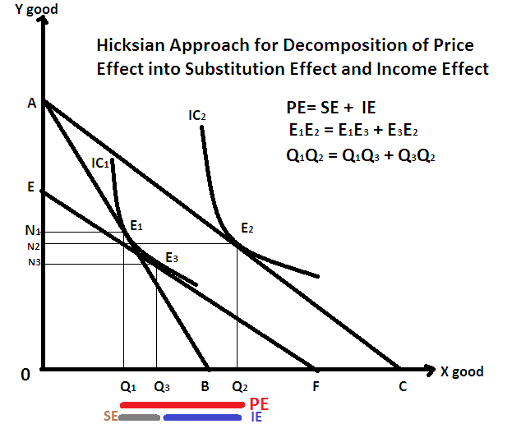

According to Hicksian approach, in order to separate PE into SE and IE, we keep real income constant by compensating the consumer if the consumer's real income increases due to fall in the price of a commodity, we taxed him/her in order to keep his real income constant. But if the consumer's real income decreases due to increase in the price of a commodity, we provide subsidy him/her to maintain the same level real income. According to Hicks, real income is to be constant, if the compensated budget line obtained either through taxation or through subsidy is tangent to the initial IC and parallel to the new budget line due to change in price.

The figure illustrates the separation of Price Effect (PE) into Substitution Effect (SE) and Income Effect (IE) of normal goods. Initially, the consumer is in equilibrium at E1, when his/her budget is AB. In this equilibrium, s/he consumes ON1 units of Y and X OQ1 units of X good. Now assume that price of X has decreased which swing the budget line to AC and consumer attains equilibrium at E2, when s/he is consuming OQ2 units of X as IC2 is tangent to new budget line AC. This movement from E1 to E2 is called Price Effect (PE).

Now, in order to separate Price effect (PE) into Substitute Effect(SE) and Income Effect(IE), we keep the real income constant by imposing tax to the consumer in such a way that the compensated budget line is EF, which is tangent to IC1 and parallel to new budget line AC. This shows that if the real income is kept constant, the consumer will be in equilibrium at E3, even though the price of X declines. Therefore, the movement from E1 to E3 is Substitution Effect (SE) because this shows if the real income is held constant, the consumer will consume Q1Q3 more quantity of X commodity being it is relatively cheaper.

Now if we rebate (give back) the hypothetically taxed amount to the consumer, s/he will move back to E2 from E3. This is income effect (IE) because while moving from E3 to E2, the consumer's income has increased equivalent by the taxed amount. Here, income effect (IE) is positive being the normal good.

Movement from E1 to E2= PE= Q1Q2

Movement from E1 to E3= SE= Q1Q3

Movement from E3 to E2= IE= Q3Q2.

Here the movement of SE and IE are uni-direction and so the direction of PE is also at the same direction.

Thus, PE=SE+IE as Q1Q2= Q1Q3+ Q3Q2.

1. Define the law of supply and why does supply curve slopes upward to the right?

Other things being equal, Supply of a commodity varies positively with price of same commodity is called Law of supply. Or, the law with higher the price, higher the supply quantity and lower the price lower the supply quantity is called law of supply. Law of supply can be understood by supply schedule as below in the table:

Table 1:

|  |  |
| --- | --- |
| Price (in Rs) | Quantity Supplied of X good |
| 50 | 200 |
| 60 | 300 |
| 70 | 400 |
| 80 | 500 |
| 90 | 600 |

Explain table…

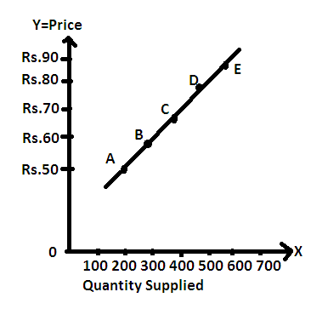

Explain the figure ……

The Law of Supply is based on the following assumption:

1. There should be no change in the price of other goods.
2. Goals of the producers are fixed.
3. There is constant technology in production.
4. There should be no change in tax policy.
5. prices of factors of production remain constant

Supply Curve slopes upward to the right due to operation of the law of the supply as suppliers/producers have the tendency of supplying the more quantities when higher the price and supplying the less quantities when lower the price of a product. So, the supply curve slopes upwards to the right due to following reasons:

1. Supply increases due to rise in the prices are:
2. Producers are ready to offer larger quantities from their old stock (stock clearance).
3. Due to higher profit possibilities in raising the price of product, producers expand their production capacity to increase production.
4. Due to the profit environment, new firms enter in the market and supply increases.
5. Supply decreases due to fall in the prices are:
   1. Producers are ready to keep the goods as the stock by withdrawing them from the market (stocking).
   2. Due to lower profit possibilities in situation of the price of product falling, producers contract their production capacity to decrease production.
   3. Due to the Loss environment, some inefficient firms exit from the market and supply decreases.

Thus in the short, supply rises to in increasing price situation due to old stock clearance, increasing production capacity by existing firms and new entry of firms in the market but in decreasing price situation, supply is decreased by producer to minimize loss by keeping them in the stock, by contracting production capacity of factory and by exiting the inefficient firm from the market.